Chapter 10: The Environment and Change over Time Lesson 1: Theory of Evolution by Natural Selection
Charles Darwin
- Charles Darwin was an English naturalist who, in the mid-1800s, developed a theory of how evolution works.
- A naturalist is a person who studies plants and animals by observing them.
Darwin worked as a naturalist on the HMS Beagle, a ship of the British navy. During his trip around the world, Darwin observed and collected many plants and animals.
- Darwin was interested in the organisms he saw on the Galápagos Islands. These islands are 1,000 km off the South American coast in the Pacific Ocean.
Darwin saw that each island had a slightly different environment. Some were dry. Some were more humid. Others had mixed environments.
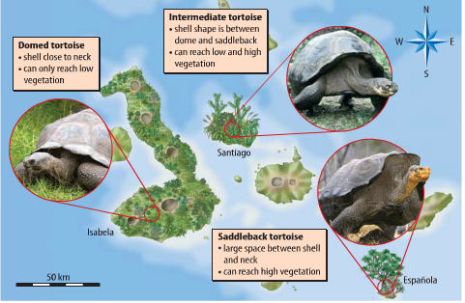

Tortoises
Darwin saw that the giant tortoises on each island looked different.
- On one island, tortoises had shells that came close to their necks. They could eat only short plants.
- On other islands, tortoises had more space between the shell and neck. They could eat taller plants.
Mockingbirds and Finches
Like the tortoises, different types of mockingbirds and finches lived in different island environments. Later, he was surprised to find that many were different enough to be separate species.

Darwin’s Theory
Darwin discovered a relationship between each species and the food found on the island where it lived.
- Tortoises with long necks lived on islands that had tall cacti.
- The tortoises with short necks lived on islands that had plenty of short grass.
Common Ancestors
- Darwin became convinced that all the tortoise species were related. He thought they all shared a common ancestor.
- He suggested that millions of years before, a storm had carried a group of tortoises to one of the islands from South America. In time, the tortoises spread to the other islands. Their neck lengths and shell shapes changed to match their islands’ food sources.

Variations
A variation is a slight difference in the appearance of individual members of a species.
- Variations arise naturally in populations. They occur in the offspring as a result of sexual reproduction.
- Variations are caused by random mutations, or changes, in genes.
- Mutations can lead to changes in phenotype. Genetic changes to phenotype can be passed on to future generations.

Natural Selection
Natural selection is the process by which populations of organisms with variations that help them survive in their environments live longer, compete better, and reproduce more than those that do not have the variations.
- Natural selection explains how Galápagos tortoises became matched to their food sources, as shown below.
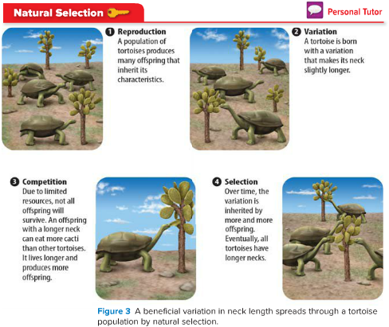
Adaptations
An adaptation is a characteristic of a species that enables the species to survive in its environment. The long neck of certain species of tortoises is an adaptation to an environment with tall cacti.

Types of Adaptations
Scientists classify adaptations into three categories: structural, behavioral, and functional.
- Structural Adaptations - These adaptations involve color, shape, and other physical characteristics. The shape of a tortoise’s neck is a structural adaptation.
- Behavioral Adaptations - The way an organism behaves or acts is a behavioral adaptation. Hunting at night and moving in herds are behavioral adaptations.
- Functional Adaptations - The last category is functional adaptations. These adaptations involve chemical changes in body systems. A drop in body temperature during hibernation is a functional adaptation.
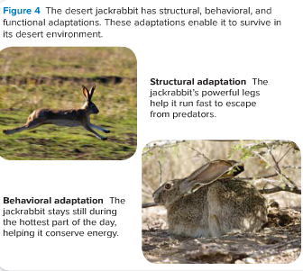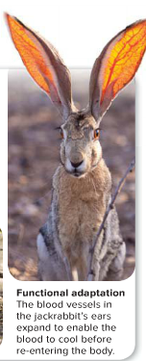
Environmental Interactions
Many species have evolved adaptations that make them nearly invisible.
For example, a seahorse may be the same color as and similar in texture to the coral it rests on.
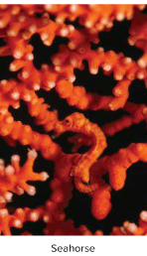This is a structural adaptation called camouflage. Camouflage is an adaptation that enables species to blend in with their environments.

Some species have adaptations that draw attention to them or make them more visible.
A caterpillar may resemble a snake. Predators see it and are scared away. The resemblance of one species to another species is mimicry.
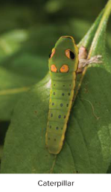
Role of Environment
Environments are complex. Species must adapt to an environment’s living parts as well as to its nonliving parts.
- Some nonliving things are temperature, water, nutrients in soil, and climate. Deciduous trees shed their leaves due to changes in climate.
- Camouflage, mimicry, and mouth shape are adaptations mostly to an environment’s living parts.
Extinct Species
If a species is unable to adapt, it becomes extinct. The fossil record contains many fossils of species unable to adapt to change.

Artificial Selection
Darwin also had a hobby of breeding pigeons. He bred pigeons of different colors and shapes. In this way, he produced new, fancy varieties.
- The breeding of organisms for desired characteristics is called selective breeding.
- Darwin saw that changes caused by selective breeding were much like changes caused by natural selection.
- Instead of nature selecting variations, humans selected them. Darwin called this process artificial selection. Artificial selection explains and supports Darwin’s theory.
- 